# Test for regular Plan Member - Spouse

P: 77197

C: 100014

Name: Matthew Park

Birth: Dec 23, 1980

ROCID: 182326

USERID: MP00167376

Register the plan member:

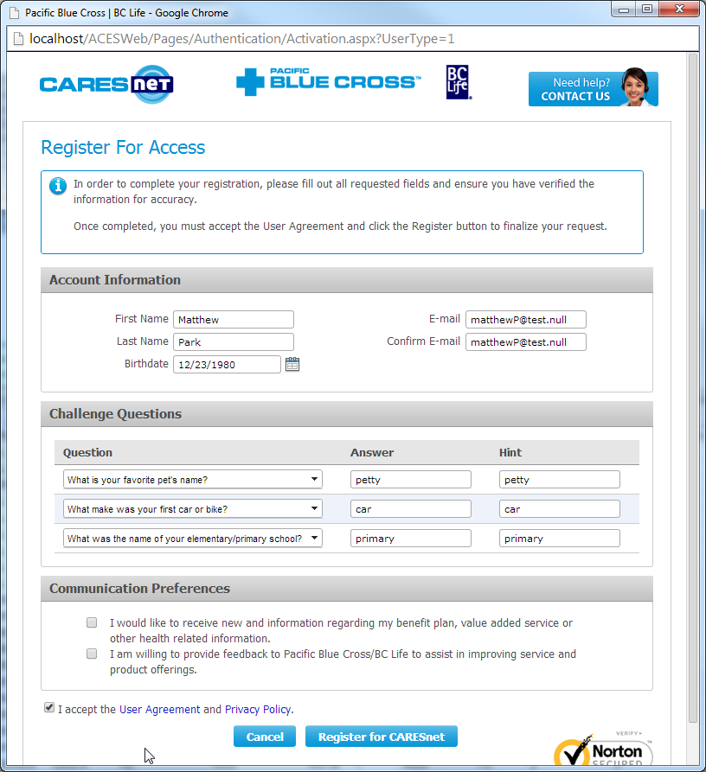

When registration not complete, query again, the PM should still be picked up. (yes)

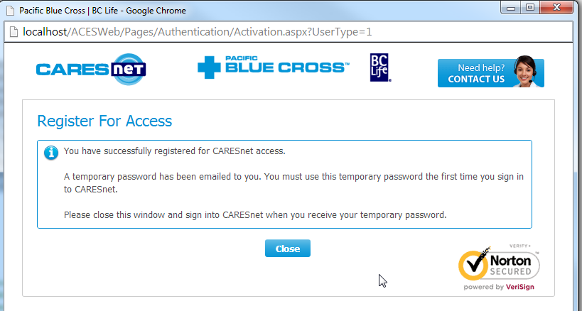

After registration completed, the SendWelcomePackage DT should still = NULL. (yes)

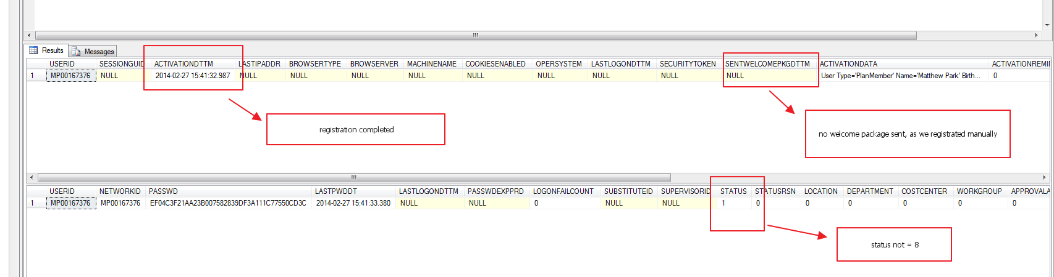

But the User Web Account status = Active, so this PM should not be picked up by Batch program. (yes)

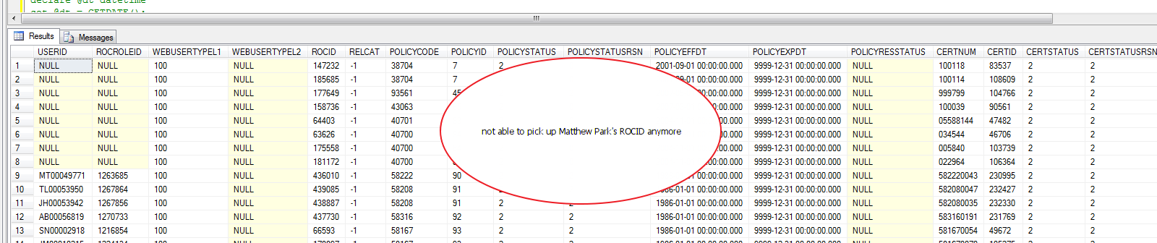

Query certificate and look for Matthew’s spouse’s status.

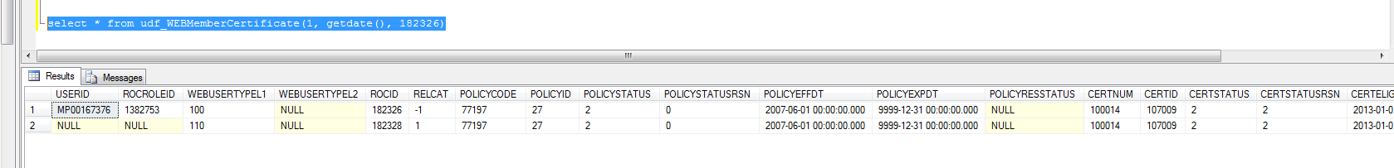

He has a spouse and the spouse does not have web account yet.

Now login CARESnet using Matthew Park’s ID. (Will be asked to change password)

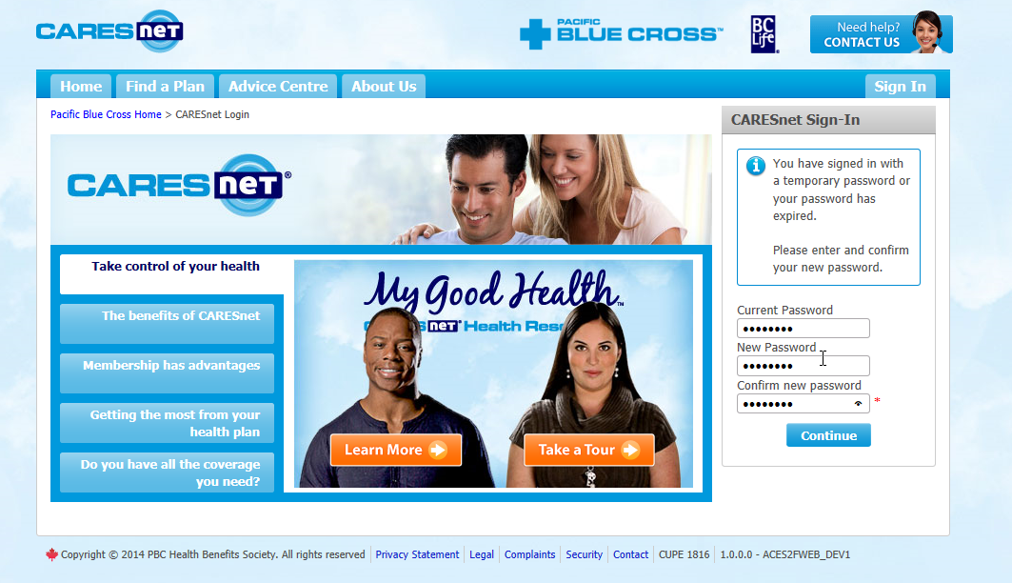

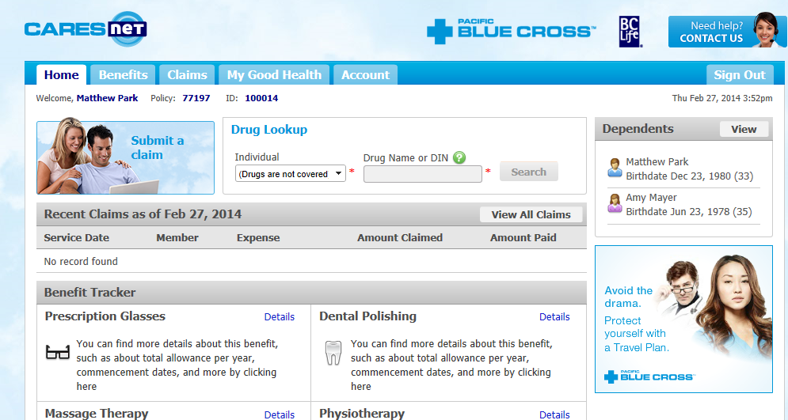

See there is a spouse named “Amy Mayer”

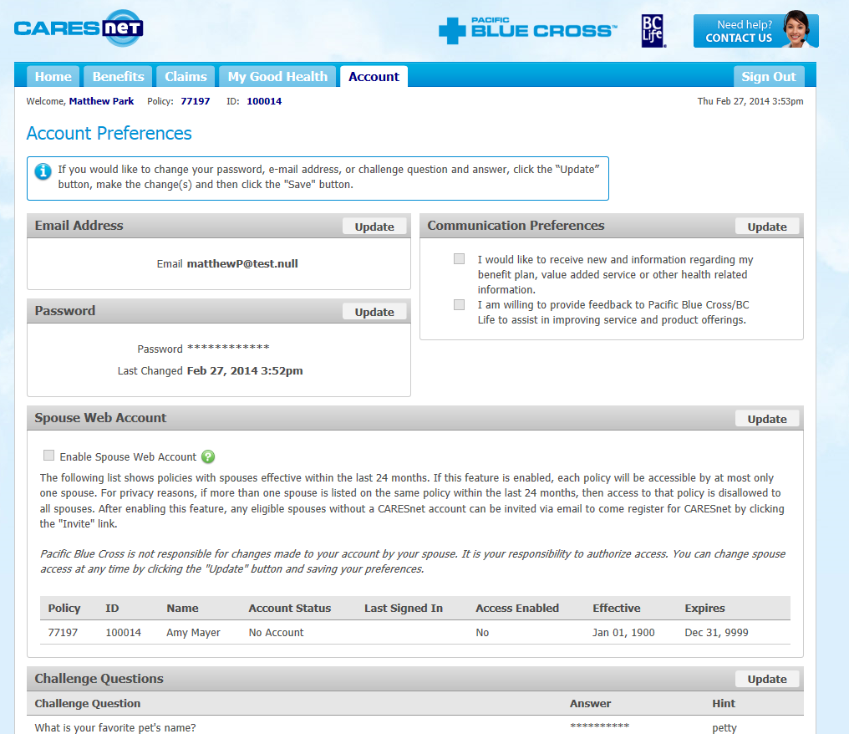

Now this spouse is not enabled to have web access yet, so she should not be picked up by batch program.

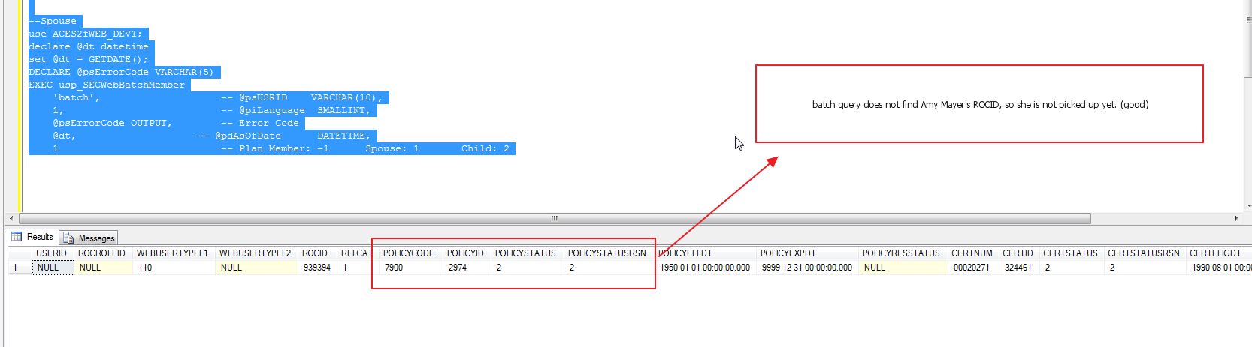

Let’s enabled the web access for Amy

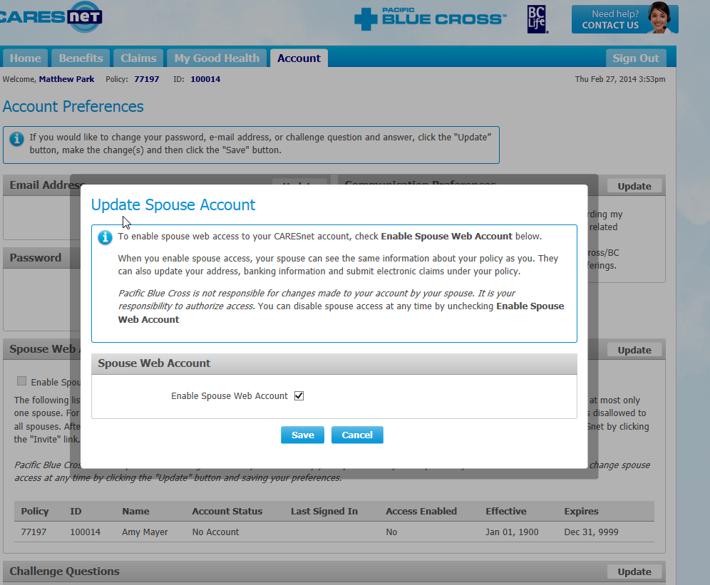

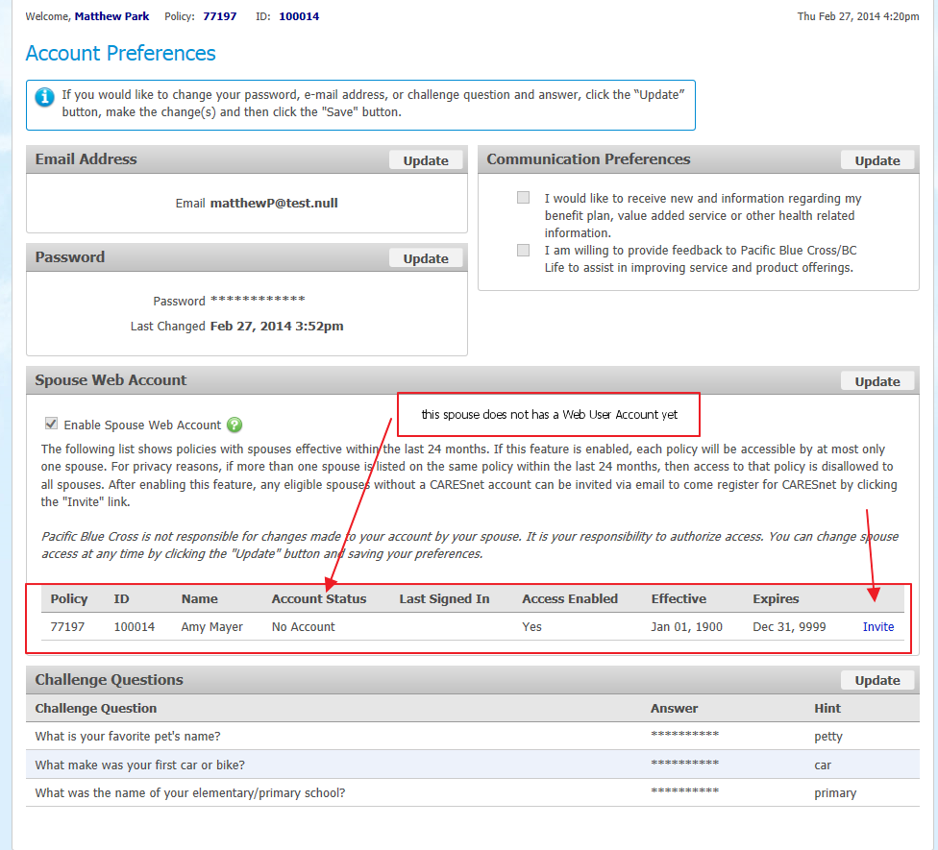

Now we are able to invite this spouse for this particular Policy/ID.

Up to this stage, PM updated his profile “PMWEBACCESS” flag to 1.

But the spouse “Amy” does not have web account created yet.

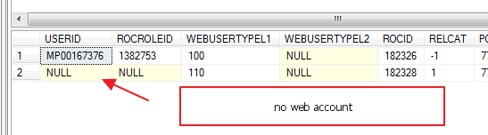

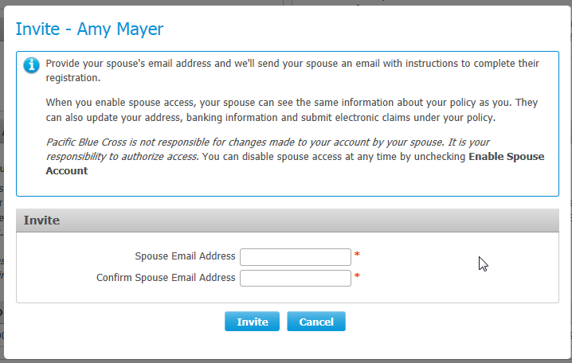

Now try to invite this spouse, there is no email address pre-populated, so she does not have email registered in ACES Core under her ROC info.

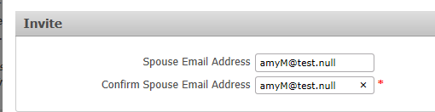

Now we entered an email address, and this will be updated in her ROC record, and a ***Spouse Invite*** email will be sent to this email address.

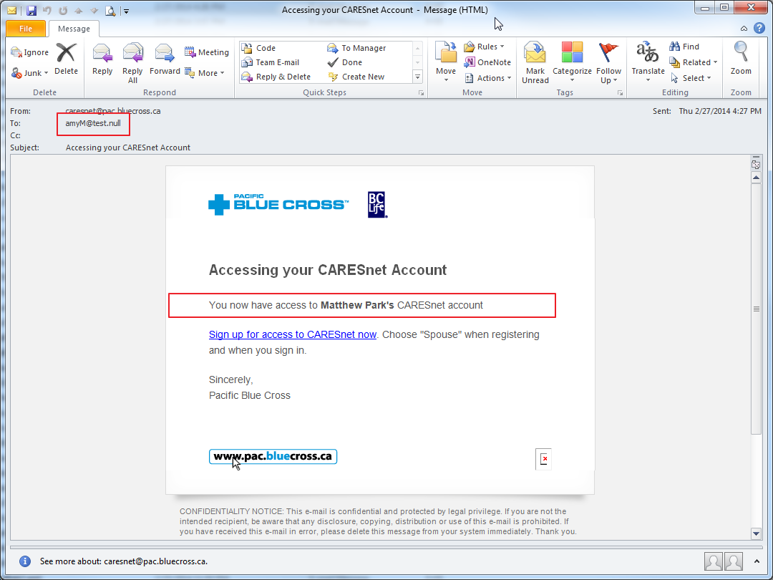

Now the batch program query should pick up this spouse “Amy”.

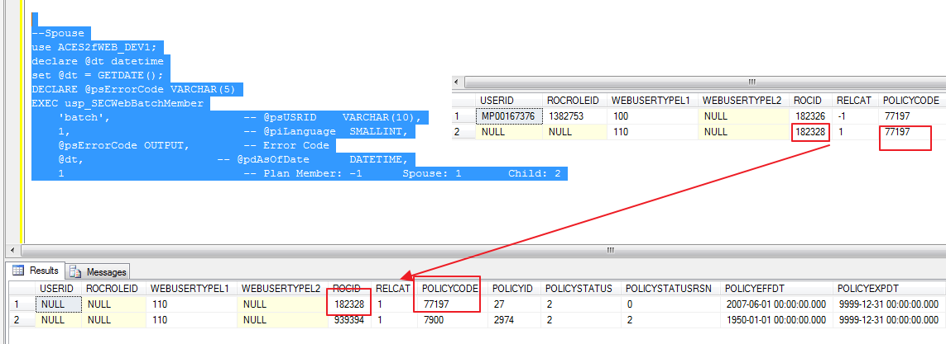

Confirmed, the spouse Amy Mayer is picked up by batch program because:

* She does not have USER ID
* Her husband (Plan Member) has enabled her web access.

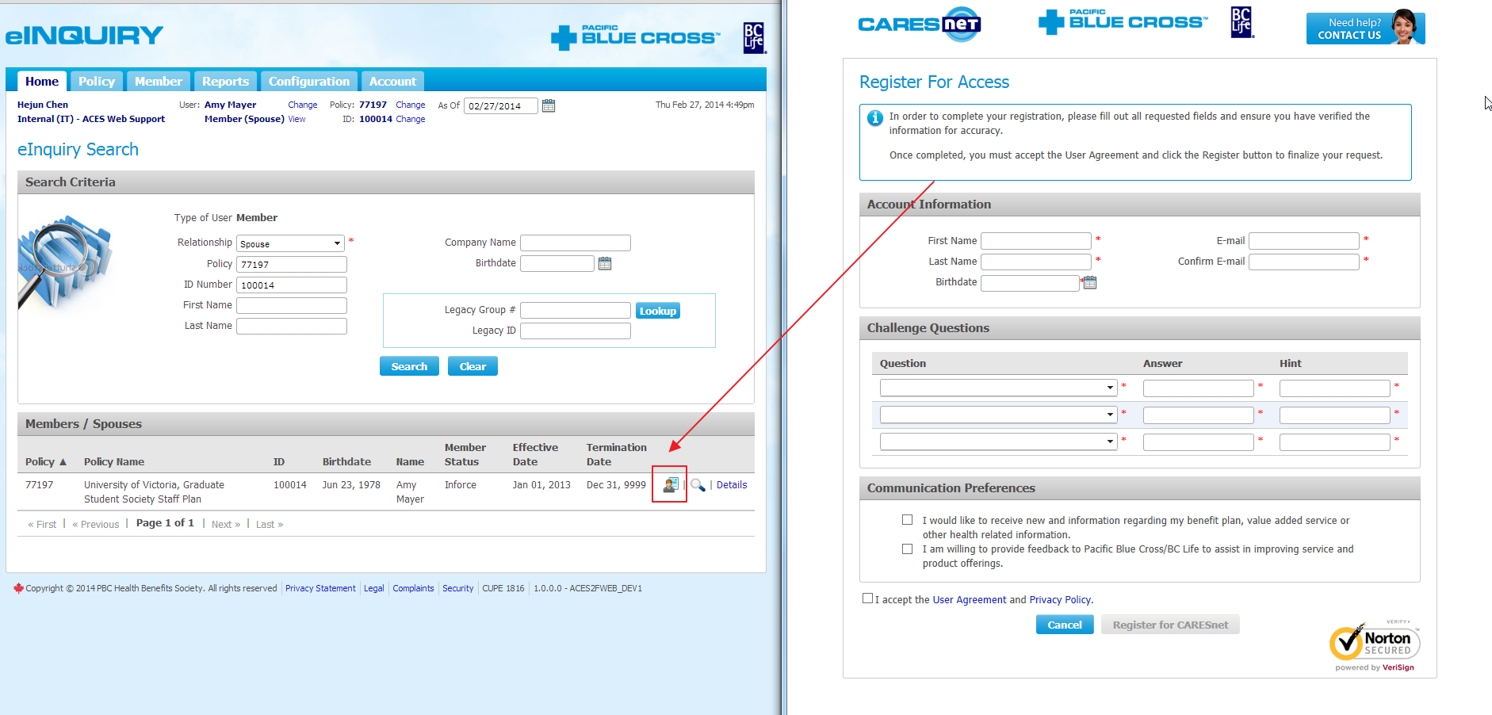

Now start registering the spouse “Amy”.

The 2nd step of registration will confirm Amy’s web user account has been created.

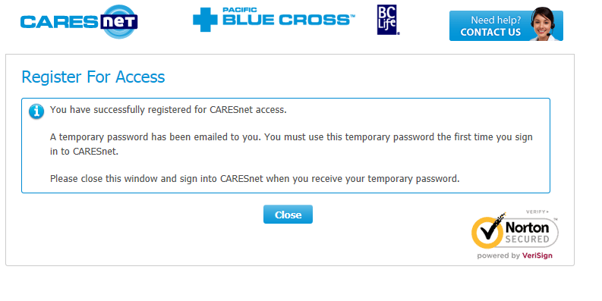

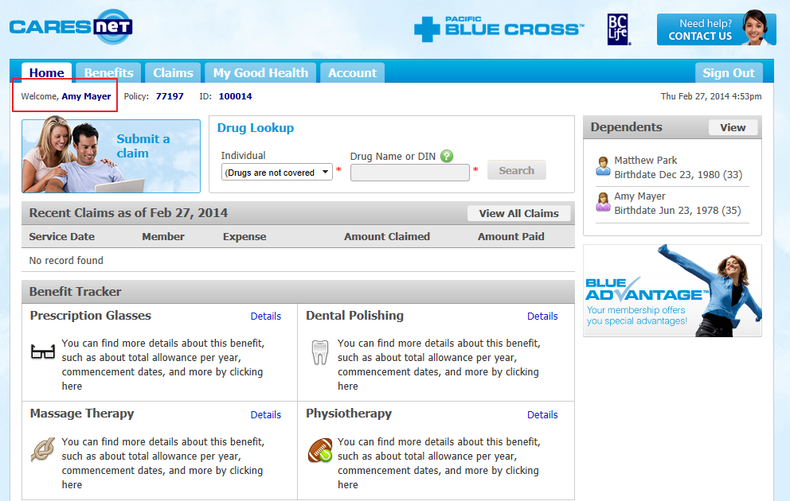

Now Amy has registered successfully. The batch program should not pick her up again. (yes)

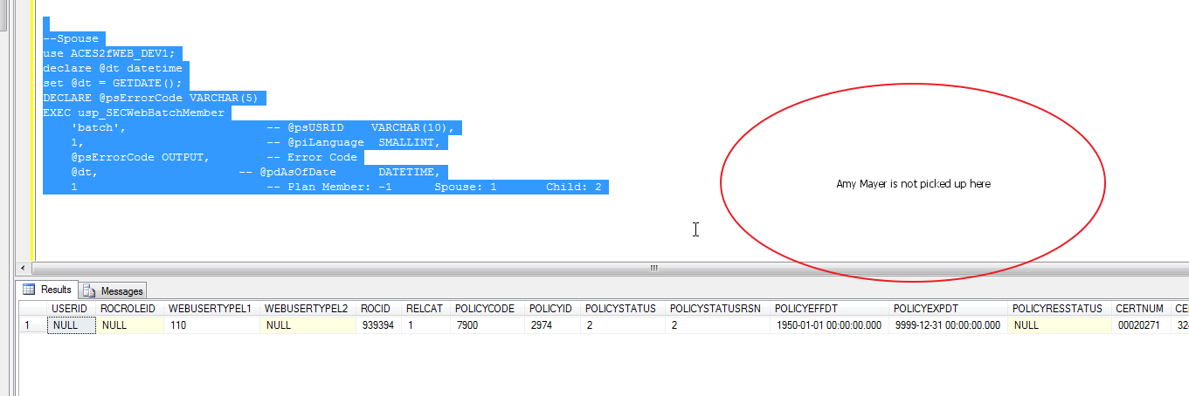

# Test for ROC who is Plan Member and Spouse

Same ROC, as Plan Member and Spouse for two different POLICY/CERT.

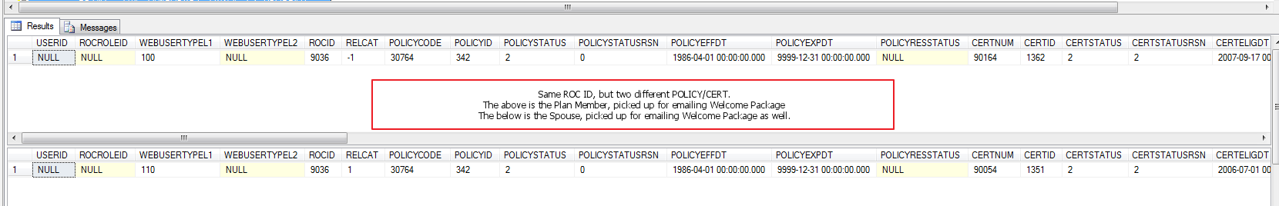

If we query for Plan Member, we should pick it up and send the welcome package email.

After that, query for Spouse again, we should NOT pick it this user anymore.

Notice the user is now not having USERID.

--Plan Member

SELECT CE.*, NULL AS 'SPOUSEFIRSTNAME', NULL AS 'SPOUSEMIDDLENAME', NULL AS 'SPOUSELASTNAME', RC.CORRNUM, NULL AS 'USERGROUPID', UP.PASSWD, NULL AS 'SPOUSEWEBACCESS'

FROM VW_WEBMEMBERCERTIFICATE CE

INNER JOIN G00POLICY P ON CE.POLICYID = P.POLICYID

INNER JOIN R00ROCCONTACTINFO RC ON CE.ROCID = RC.ROCID

LEFT JOIN S00USERPROFILE UP ON CE.USERID = UP.USERID

LEFT JOIN S00WEBUSER WU ON WU.USERID = CE.USERID

WHERE CE.POLICYCODE=30764 AND CE.CERTNUM=90164 AND

(CE.LANGUAGEID = 1 AND CE.ISWASENABLED = 1 AND CE.CERTEFFDT <= GETDATE()) AND

(P.GENWEBACCT = 1) AND

(RC.DELIVERYTYPE = 4 AND RC.CORRTYPE = 7 AND (RC.CORRNUM IS NOT NULL AND RC.CORRNUM <> '')) AND

(CE.POLICYSTATUS NOT IN (1,4) AND CE.POLICYRESSTATUS IS NULL) AND

(CE.CERTSTATUS NOT IN (1, 4) AND CE.CERTRESSTATUS IS NULL) AND

(CE.COVLSTATUS NOT IN (1 ,4) AND CE.COVLRESSTATUS IS NULL) AND

(CE.ISNEXUS = '0' OR CE.ISFLEX = '1') AND

(CE.USERID IS NULL OR (CE.USERID IS NOT NULL AND UP.[STATUS] = 8 AND WU.SENTWELCOMEPKGDTTM IS NULL)) AND

(CE.RELCAT = -1);

-- Spouse

-- PRE-CHECK THE TEMP TABLE, IF EXISTS, DELETE IT

IF OBJECT_ID('TEMPDB..#TBLRESULT_SPOUSE') IS NOT NULL

DROP TABLE #TBLRESULT_SPOUSE;

-- GET THE DISTINCT LIST OF POLICY ID AND CERTIFICATE ID WHERE THE PLAN MEMBER (INSURED) PMWEBACCESS = 1

WITH DISTINCTPOLICYANDCERT AS

(

SELECT DISTINCT CE.POLICYID, CE.CERTID

FROM VW_WEBMEMBERCERTIFICATE CE

INNER JOIN S00USERPROFILE UP ON CE.USERID = UP.USERID

WHERE UP.PMWEBACCESS = 1

)

SELECT CE.*, PE.FIRSTNAME AS 'SPOUSEFIRSTNAME', PE.MIDDLENAME AS 'SPOUSEMIDDLENAME', PE.LASTNAME AS 'SPOUSELASTNAME', RC.CORRNUM, NULL AS 'USERGROUPID', UP.PASSWD, 0 AS 'SPOUSEWEBACCESS'

INTO #TBLRESULT_SPOUSE

FROM VW_WEBMEMBERCERTIFICATE CE

INNER JOIN G00POLICY P ON CE.POLICYID = P.POLICYID

INNER JOIN R00ROCCONTACTINFO RC ON CE.ROCID = RC.ROCID

INNER JOIN DISTINCTPOLICYANDCERT DPC ON CE.POLICYID = DPC.POLICYID AND CE.CERTID = DPC.CERTID

LEFT JOIN S00USERPROFILE UP ON CE.USERID = UP.USERID

LEFT JOIN S00WEBUSER WU ON WU.USERID = CE.USERID

LEFT JOIN R00ROC ROC ON CE.ROCID = ROC.ROCID

LEFT JOIN R00PERSON PE ON ROC.PERSONCORPID = PE.PERSONID

WHERE CE.POLICYCODE=30764 AND CE.CERTNUM=90054 AND

(CE.LANGUAGEID = 1 AND CE.ISWASENABLED = 1 AND CE.CERTEFFDT <= GETDATE()) AND

(P.GENWEBACCT = 1) AND

(RC.DELIVERYTYPE = 4 AND RC.CORRTYPE = 7 AND (RC.CORRNUM IS NOT NULL AND RC.CORRNUM <> '')) AND

(CE.POLICYSTATUS NOT IN (1,4) AND CE.POLICYRESSTATUS IS NULL) AND

(CE.CERTSTATUS NOT IN (1, 4) AND CE.CERTRESSTATUS IS NULL) AND

(CE.COVLSTATUS NOT IN (1 ,4) AND CE.COVLRESSTATUS IS NULL) AND

(CE.ISNEXUS = '0' OR CE.ISFLEX = '1') AND

(CE.USERID IS NULL OR (CE.USERID IS NOT NULL AND UP.[STATUS] = 8 AND WU.SENTWELCOMEPKGDTTM IS NULL)) AND

(CE.RELCAT = 1)

PRINT 'A SPOUSE LIST IS RETURNED (ONLY THE POLICY & CERTIFICATE WHERE THE PLAN MEMBER PMWEBACCESS = 1)...'

-- CONTINUE TO FURTHER CHECK AND SET THE SPOUSE WEB ACCESS STATUS USING THE UDF

UPDATE #TBLRESULT_SPOUSE SET SPOUSEWEBACCESS = DBO.UDF_SECWEBRESOLVESPOUSEACCESS(COVLIVEID, GETDATE())

PRINT 'UPDATED THE SPOUSE LIST AND RESET THEIR WEB ACCESS STATUS RESOLVED FLAG BY USING UDF_SECWEBRESOLVESPOUSEACCESS() FUNCTION... '

-- RETURN THE SPOUSE WHO IS THE CURRENTLY ACTIVE TO WEB ACCESS

SELECT * FROM #TBLRESULT_SPOUSE WHERE SPOUSEWEBACCESS = 1

PRINT 'THE SPOUSE LIST QUERY IS COMPLETED...'

-- DUMP THE TEMP TABLE

DROP TABLE #TBLRESULT_SPOUSE

PRINT 'THE TEMPORARY TABLE IS DROPPED...’

Now register this user but stop at the 2nd step (Activation). This user semi-registered so the Web User Account is created, but the registration is not completed yet.

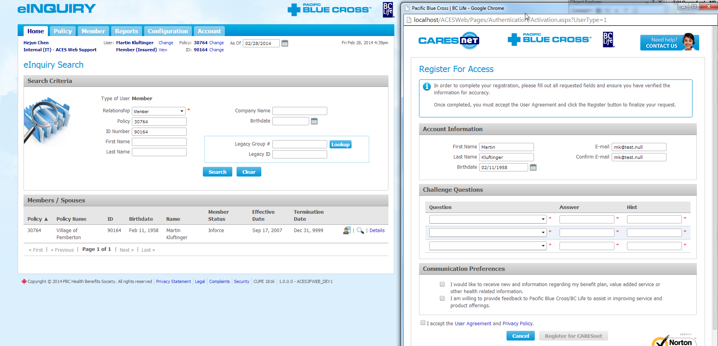

Do not complete the registration, but cancel the registration wizard from here.

Query again, see this user now has USER ID and he is ready for welcome package email as both Plan Member and Spouse.

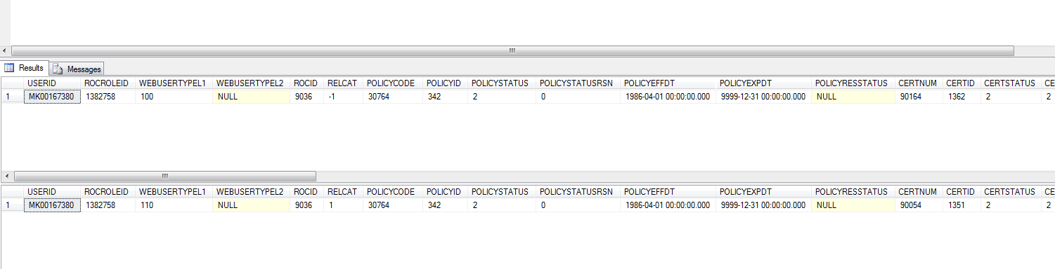

Now let’s force to send a welcome package email to this user (Plan Member).

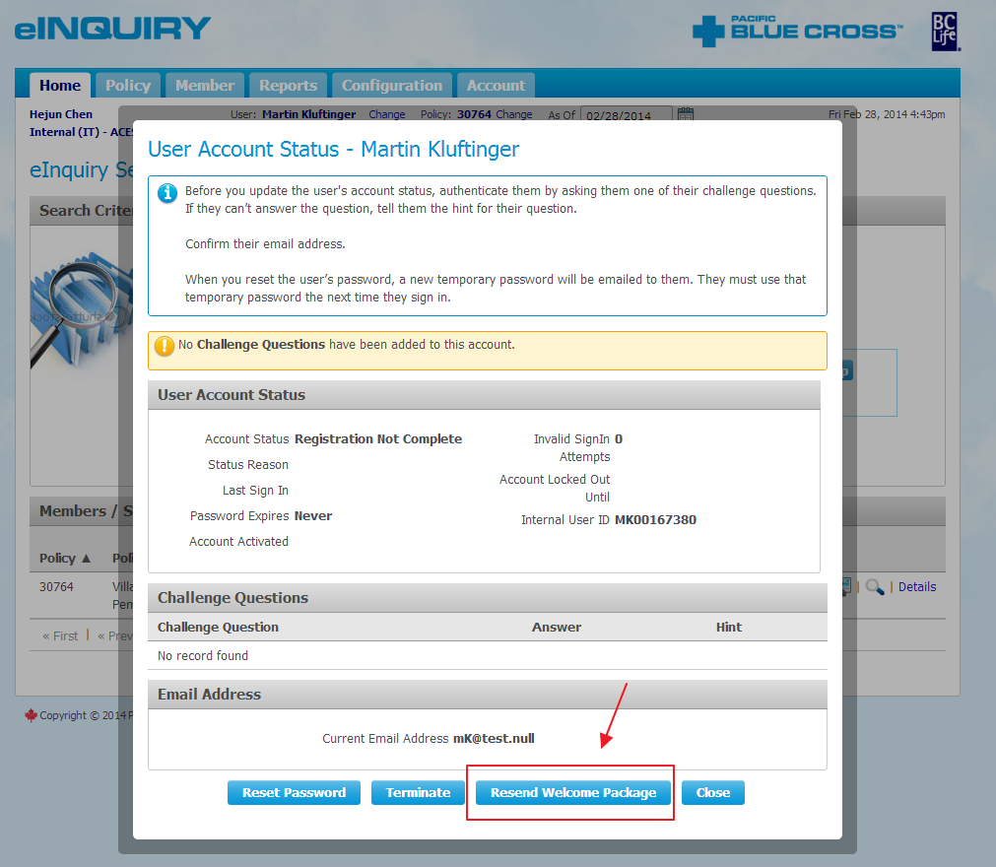

Once the welcome package is sent out, this user should not be picked up in bath program as Plan member, neither as Spouse.

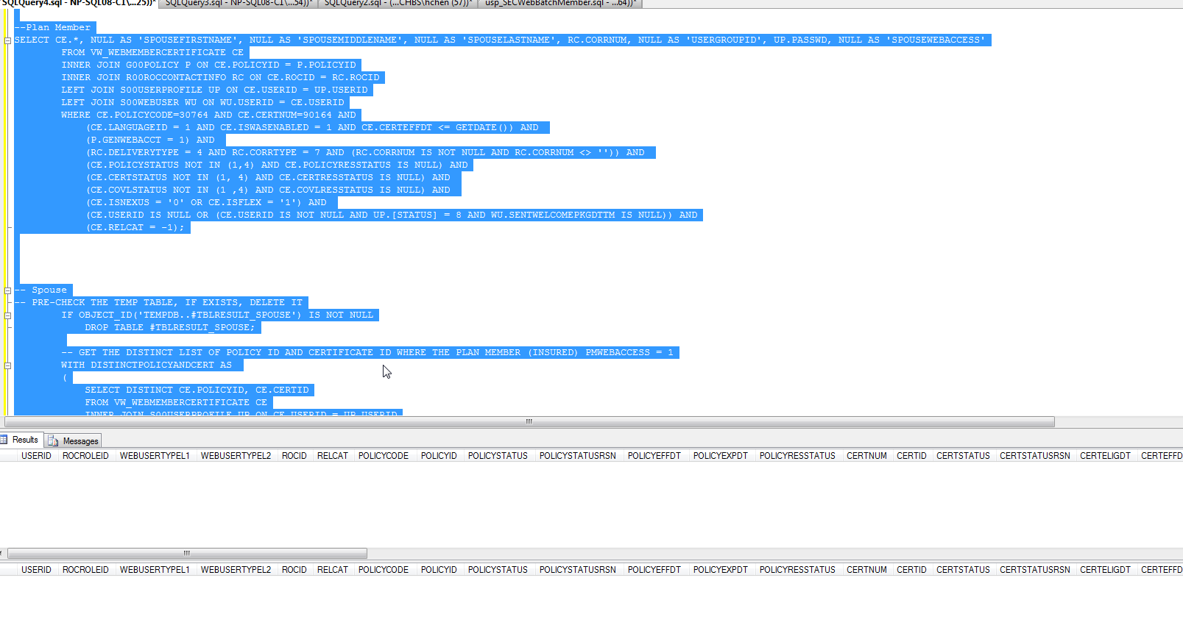

Ran the query again for check if this user will be picked up as Plan Member or Spouse.

The result shows this user (ROC) disappeared from the batch query list so we will not send a 2nd welcome package to this user for Spouse list anymore. The same ROC person should not be picked up for sending welcome package email twice.